Mount Rainier Report and Analysis

Overall Average Success Rate Per Route

February 2021 - Catharina van Veen

# Introduction

Washington state has begun production for their new tourist website. One of the enticing features they would like to add is the statistics of the success rate in which people climb Mount Rainier. Besides just the success rate they have some other questions they need answered which could have an impact on the registration fee, when to advertise to potential tourists, the possibility to hire more park rangers for safety in bad weather conditions and so forth.

They have tasked the National Park Services to collect this data for them to contract out to a Data Science Team.

The client would like the overall average success rates per route. This will be the scope of this report.

# Data

For this report I used the data and information about Mount Rainier climbing statistics contained in the provided file, climbing_statistics.csv.

The data consists of 4,077 rows and 6 columns all related to Mount Rainier climbing statistics and metrics. Each row represents a party of climbers and provides the following information: date, route, number of failed attempts (incorrectly labeled as attempts), number of successes, and ratio between succeeded attempts and number of failed attempts (incorrectly labeled as success percentage). There are no cells with missing or inconsistent data.

For the purpose of this report, I did not need the ratio between succeeded and failed, so I dropped that column. I added a column to record the total number of attempted (failed + succeeded) and to record the success ratio (succeeded/attempted). I corrected the label of the column for failed attempts. The range of succeeded per party was 0 through 71, the range of failed per party was 1 through 26, and the range of attempted per party was 1 through 76. The success rate ranges from 0 through 93%.

The date was recorded as a string. I converted this to a datetime object. The data covers the period from 4-JAN-2014 through 27-NOV-2015, a period of 693 days. For 391 of these days there exists at least one record. After filtering for the most popular route, the data covers the period from 5-JAN-2014 through 27-NOV-2015, a period of 692 days. For 330 of these days there exists at least one record.

The data has 26 unique routes. Two of these were obvious misspellings of ‘Fuhrer Finger’ and those records were corrected, leaving us with 25 unique route names.

# Method

I calculated overall success rates based on the total individual attempts. I also calculated the averages of the daily success rates. Then I compared the routes based on both these calculations.

I chose to use both these methods to anticipate any impact of specific weather conditions on a particular day, which might cause more or fewer attempts on that day and thereby skew the overall success rate.

# Results

With both methods Tahoma Cleaver comes out with the highest success rate. In the next three for both methods are Disappointment Cleaver, Kautz Glacier, and either Ptarmigan RIngraham Directge or Emmons-Winthrop.

Since there were only 6 attempts for Tahoma Cleaver, the number may not be representative. However, Disappointment Cleaver, Kautz Glacier, and Emmons-Winthrop show the highest number of attempts, therefor these rates are the most reliable.

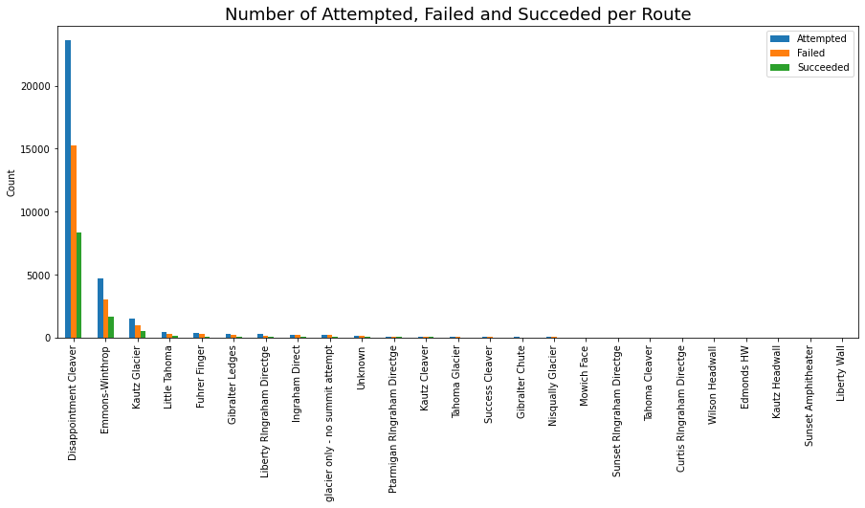

**Less than 10 Attempts**

